***Group 3***:- *Report 2*

**CSE523 Machine Learning**

**Heart Attack Prediction**

| **Group Members** | **Roll No** |
| --- | --- |
| **Shivam Thakker** | **AU1940193** |
| **Devarsh Sheth** | **AU1940189** |
| **Pranav Gandhi** | **AU1940313** |
| **Meet Jhaveri** | **AU1940284** |

* As we mentioned earlier in report 1, we did missing value analysis, unique value analysis, Categorical value analysis, Numeric value analysis and standardization.
* Then we further carried out Box plot analysis using pd.DataFrame() by passing scaledArray which we got by doing standardization previously. Then we used pd.concat()
* Then we will pd.melt() which will print data with 3 columns:- output, features and values and has 19 rows.
* Now when we plot the figure using sns.boxplot() with giving it x = “features” , y = “value” and hue = “output”, we get graph as given below:-

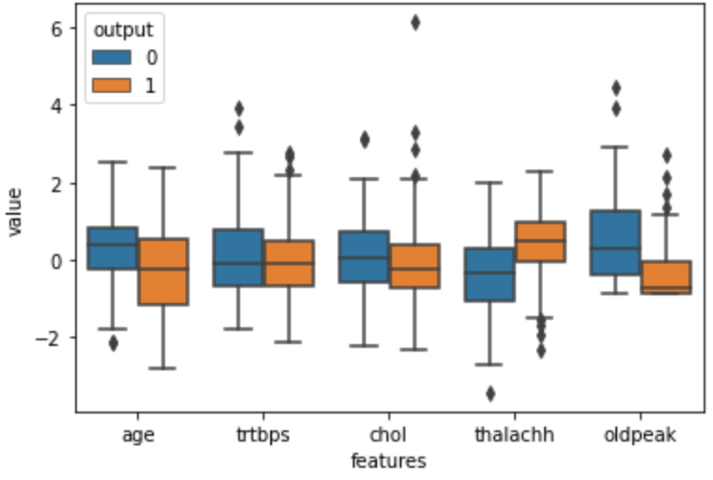

* Further we did swarm plot analysis using sns.swarmplot() with x = “features”, y = “value” and hue = “output”. Below is the graph output:-

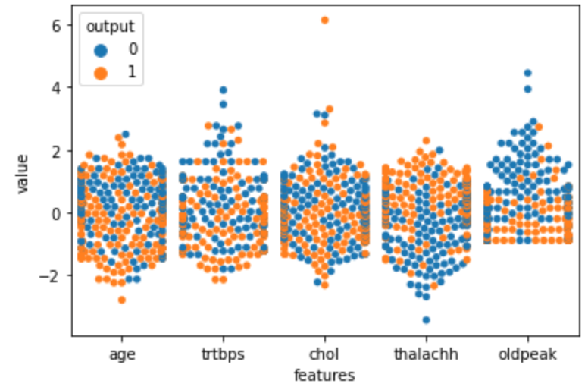

* Now, we will also do catplot analysis using sns.catplot() with parameters x = "exng", y = "age", hue = "output", col = "sex", kind = "swarm”

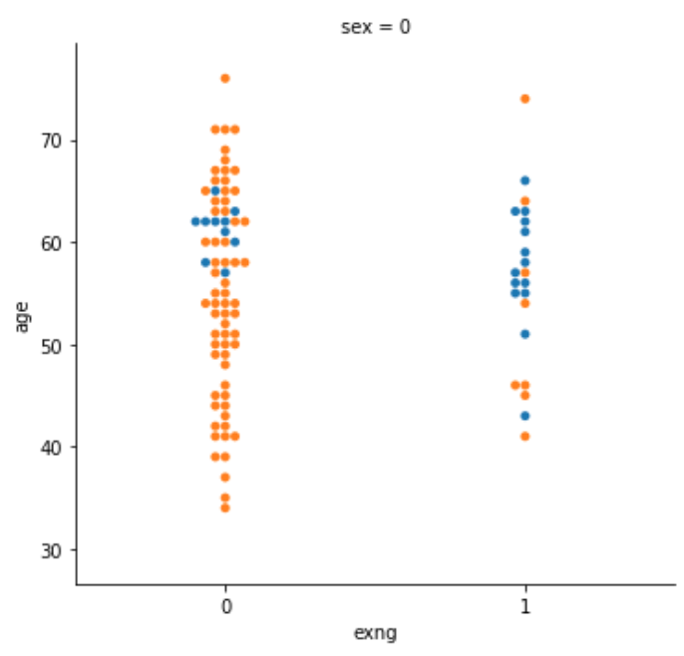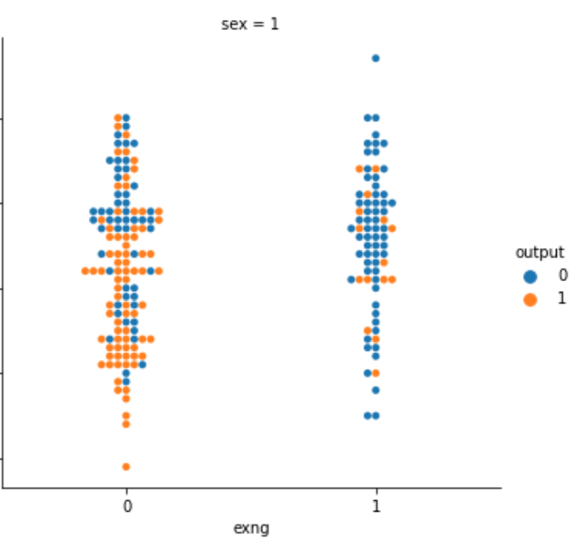

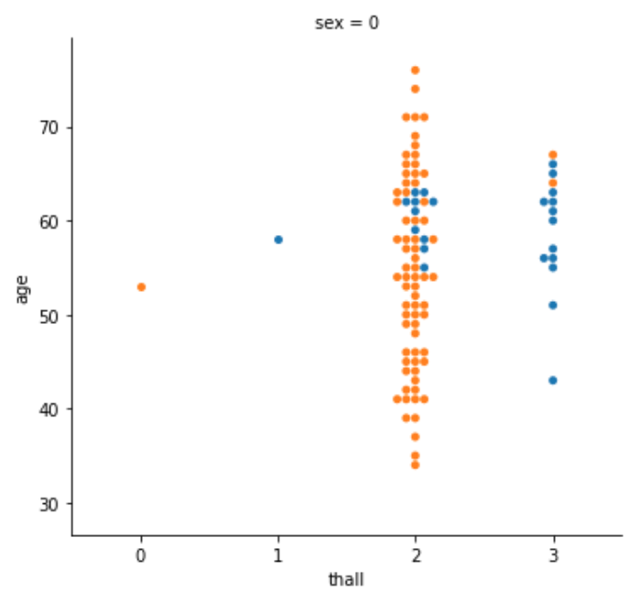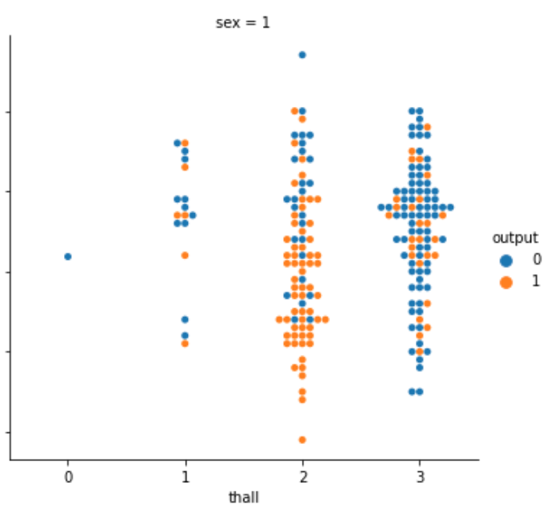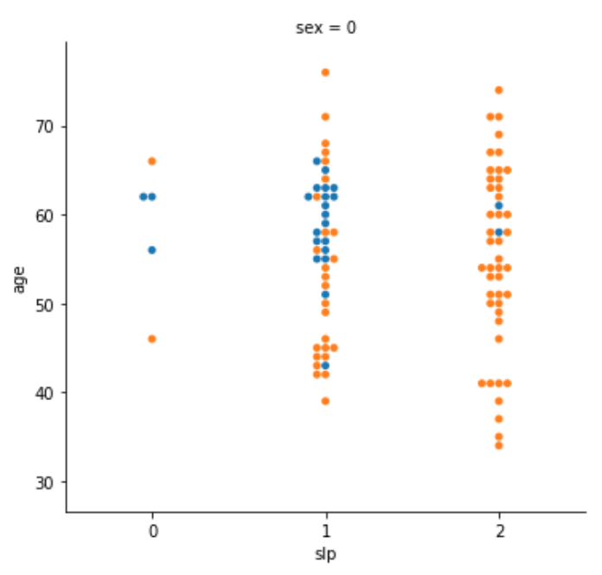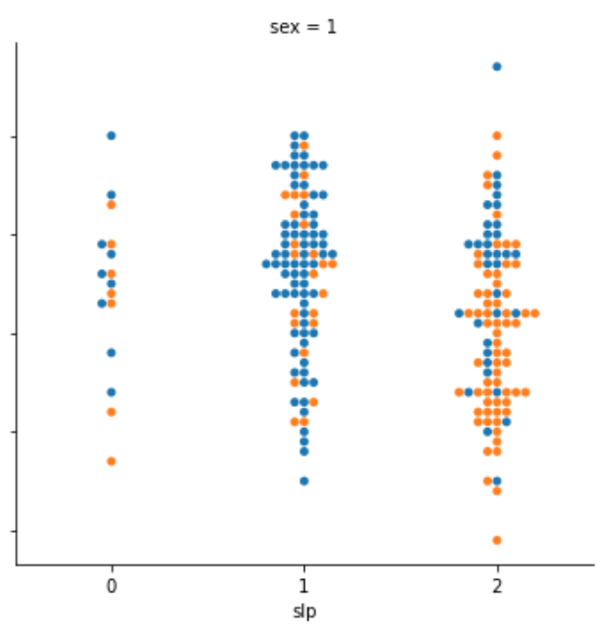

We understood more about the data by plotting above graphs. We are also noticing the pattern of correlation and we will do correlation analysis further.

***Thankyou!***